**ENGINEERING JOURNAL TEMPLATE**

# Date

11th-15Nov

# Tasks

* Research MQTT and get basic examples going. **MQTT** stands for Message Queuing Telemetry Transport. It is a lightweight publish and subscribe system where you can publish and receive messages as a client. MQTT is a simple messaging protocol, designed for constrained devices with low-bandwidth. So, it's the perfect solution for Internet of Things applications.

# Reflection

* MQTT looks like it will work for my project,if I can get it working! Can publish and receive messages and make simple communication between multiple devices which is my goal.
* I am happy with my android app so will try my best to get a connection going between my sensor and the app. This my remaining goal for first semester.

# Issues:

*Hardware:*

Software only this week

*Software:*

Downloading mosquito(mqtt) would not install. After troubleshooting I realized I needed to update and upgrade my pi. sudo apt-get update

sudo apt-get upgrade.

# Solutions

*Hardware:*

* Working on software this week

*Software:*

Installed Mosquitto MQTT Broker on Raspberry Pi

**sudo apt update**

**sudo apt install -y mosquitto mosquitto-clients**

Got basic example working communication from one terminal to another, which is good. Now I know that the connection works and it is possible to communicate with mqtt

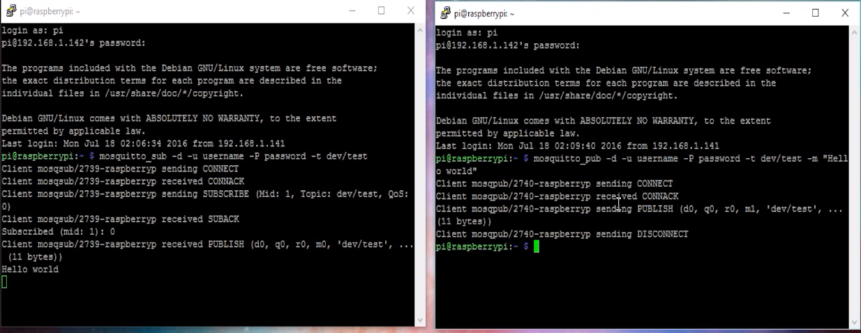

Outline on how an mqtt broker works

